Lab Assignment 2

Part 1

**1. pwd *(Print Working Directory)***

**ANS.**

$ pwd

/home/user

**2. cd *(Change Directory)***

**ANS.**

$ cd Documents/

$ pwd

/home/user/Documents

**3. ls *(List Files & Directories)***

**ANS.**

$ ls

Documents Downloads Pictures file1.txt script.sh

**4. mkdir *(Create Directory)***

**ANS.**

$ mkdir NewFolder

$ ls

Documents Downloads NewFolder Pictures file1.txt script.sh

**5. rm *(Remove Files & Directories)***

**ANS.**

$ rm file1.txt

$ ls

Documents Downloads NewFolder Pictures script.sh

**6. touch *(Create Empty File)***

**ANS.**

$ touch newfile.txt

$ ls

Documents Downloads NewFolder Pictures newfile.txt script.sh

**7. hostname *(Display System Hostname)***

**ANS.**

$ hostname

ubuntu-server

**8. cat *(Display File Content)***

**ANS.**

$ cat script.sh

#!/bin/bash

echo "Hello, World!"

**9. chmod *(Change File Permissions)***

**ANS.**

$ chmod +x script.sh

$ ls -l script.sh

-rwxr-xr-x 1 user user 34 Mar 22 11:30 script.sh

**10. echo *(Print a String)***

**ANS.**

$ echo "Hello, Linux!"

Hello, Linux!

**11. grep *(Search for a Pattern in a File)***

**ANS.**

$ grep "error" logfile.txt

error: File not found

error: Connection timeout

**12. fgrep *(Fixed-String Search - Same as grep -F)***

**ANS.**

$ fgrep "error" logfile.txt

error: File not found

error: Connection timeout

**13. mv *(Rename or Move a File)***

**ANS.**

$ mv newfile.txt renamedfile.txt

$ ls

Documents Downloads NewFolder Pictures renamedfile.txt script.sh

**14. cp *(Copy Files & Directories)***

**ANS.**

$ cp renamedfile.txt /home/user/backup/

$ ls /home/user/backup/

renamedfile.txt

**15. more *(View Large File Page by Page)***

**ANS.**

$ more largefile.txt

This is line 1

This is line 2

--More-- (Press Space to continue, 'q' to quit)

**16. less *(View Large File with Scroll Support)***

**ANS.**

$ less largefile.txt

This is line 1

This is line 2

(Press 'q' to quit)

**17. wc *(Count Lines, Words, Characters)***

**ANS.**

$ wc logfile.txt

50 200 1500 logfile.txt

(50 lines, 200 words, 1500 characters)

**18. awk *(Pattern Scanning and Processing)***

**ANS.**

$ awk '{print $1}' data.txt

apple

banana

cherry

(Displays the first column of data.txt)

**19. sed *(Stream Editor for Filtering & Modifying Text)***

**ANS.**

$ sed 's/error/warning/' logfile.txt

warning: File not found

warning: Connection timeout

(Replaces "error" with "warning")

**20. tail *(Display Last 10 Lines of a File)***

**ANS.**

$ tail logfile.txt

Line 41

Line 42

Line 43

...

Line 50

Part 2

**1. How to navigate to a Specific Directory?**

**Ans.** In Linux, we use the cd (Change Directory) command to navigate to a specific directory.

**Command and Output:**

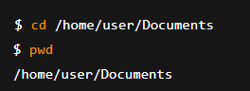

**2. How to see detailed information about files and directories using ls?**

**Ans.** The ls -l command lists files and directories in long format, displaying details such as permissions, owner, group, size, and modification date.

**Command and Output:**

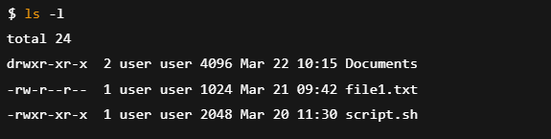

**3. How to create multiple directories in Linux using mkdir command?**

**Ans**. The mkdir command allows us to create multiple directories at once.

**Command and Output**:

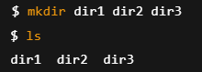

**4. How to remove multiple files at once with rm?**

**Ans**. The rm command can be used to delete multiple files simultaneously.

**Command and Output:**

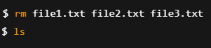

**5. Can rm be used to delete directories?**

**Ans**. Yes, rm -r is used to remove directories and their contents recursively.

**Command and Output:**

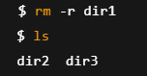

**6. How Do You Copy Files and Directories in Linux?**

**Ans.** The cp command is used to copy files. Use -r to copy directories**.**

**Command and Output:**



**7. How to Rename a file in Linux Using mv Command?**

**Ans**. The mv command is used to rename a file.

**Command and Output:**

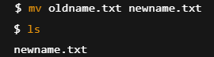

**8. How to Move Multiple files in Linux Using mv Command?**

**Ans**. The mv command moves multiple files to a new location.

**Command and Output:**



**9. How to Create Multiple Empty Files by Using Touch Command in Linux?**

**Ans**. The touch command creates multiple emptyfiles.

**Command and Output:**

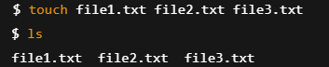

**10. How to View the Content of Multiple Files in Linux?**

**Ans**. The cat command can be used to display multiple files**.**

**Command and Output:**



**11. How to Create a file and add content in Linux Using cat Command?**

**Ans**. Using cat > filename allows adding content.

**Command and Output:**

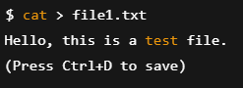

**12. How to Append the Contents of One File to the End of Another File using cat?**

**Ans**. Use cat file1 >> file2 to append content.

**Command and Output:**



**13. How to use cat command if the file has a lot of content and can’t fit in the terminal?**

**Ans**. Use less or more for large files.

**Command and Output:**



**14. How to Merge Contents of Multiple Files Using cat Command?**

**Ans**. cat file1 file2 > mergedfile merges files.

**Command and Output:**



**15. How to use cat Command to Append to an Existing File?**

**Ans**. Use >> to append.

**Command and Output:**

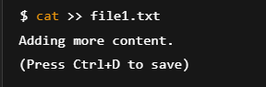

**16. What is “chmod 777 “, “chmod 755” and “chmod +x “or “chmod a+x”?**

**Ans**.

* **chmod 777:** Full permissions for all.
* **chmod 755:** Read and execute for all, write for owner.
* **chmod +x:** Adds execute permission.

**Command and Output:**

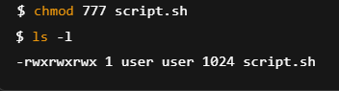

**17. How to find the number of lines that match a given string/pattern?**

**Ans**. Use grep -c to count matching lines.

**Command and Output:**



**18. How to display the files that contain the given string/pattern?**

**Ans**. Use grep -l to list filenames.

**Command and Output:**

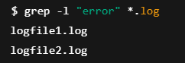

**19. How to show the line number of a file with the line matched?**

**Ans**. Use grep -n to show line numbers.

**Command and Output:**

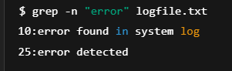

**20. How to match lines that start with a string using grep?**

**Ans**. Use grep ^pattern.

**Command and Output:**

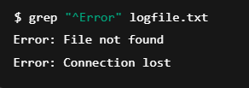

**21. Can the ‘sort’ command be used to sort files in descending order by default?**

**Ans**. By default, sort sorts in ascending order. Use -r for descending.

**Command and Output:**



**22. How can I sort a file based on a specific column using the ‘sort’ command?**

**Ans**. Use sort -k to specify a column.

**Command and Output:**

